History of the Mola

What is a Mola?
Mola, which originally meant bird plumage, is the Kuna Indian word for clothing, specifically blouse, and the word “mola” has come to mean the elaborate embroidered panels that make up the front and back of a Kuna woman's traditional blouse.

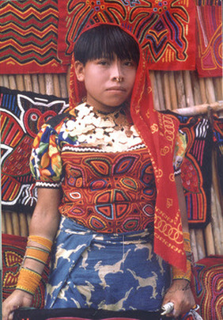

The Kuna Indians are the indigenous people who live on small coral islands in the San Blas Archipelago along the Atlantic coast of Panama and Colombia.
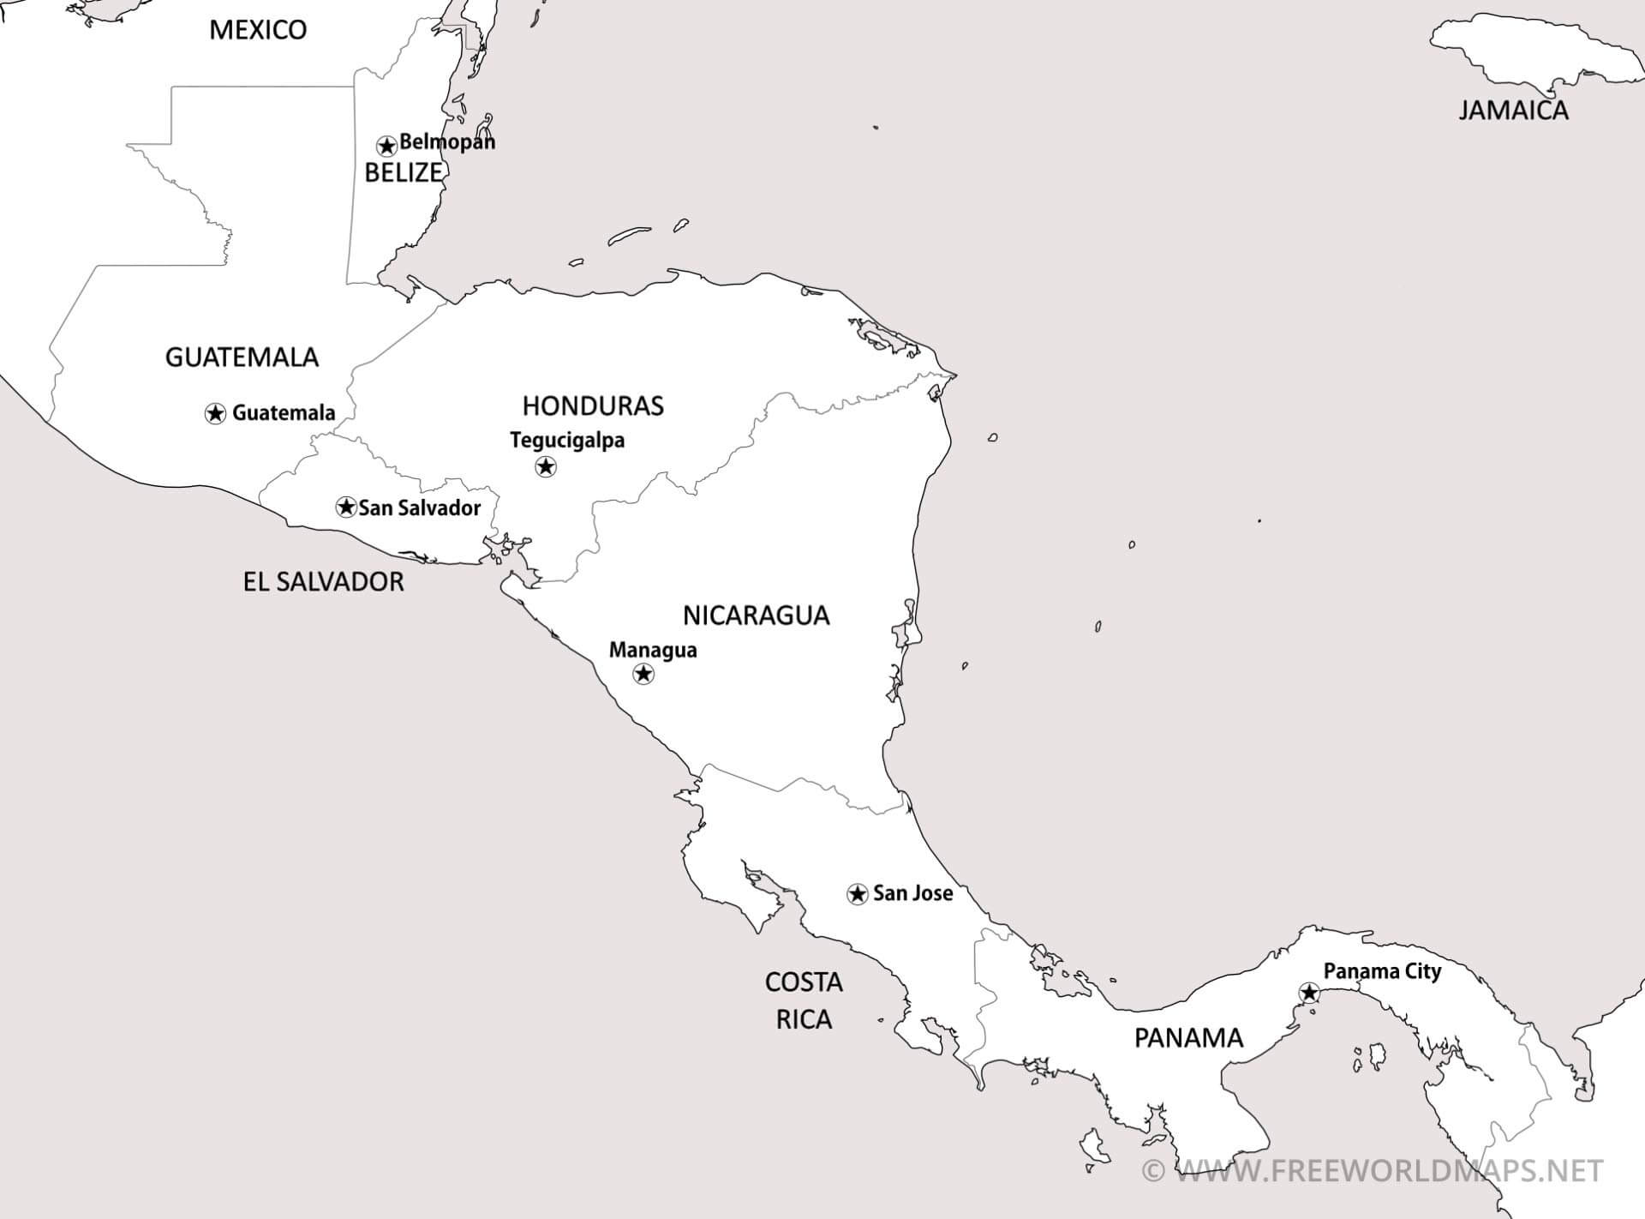

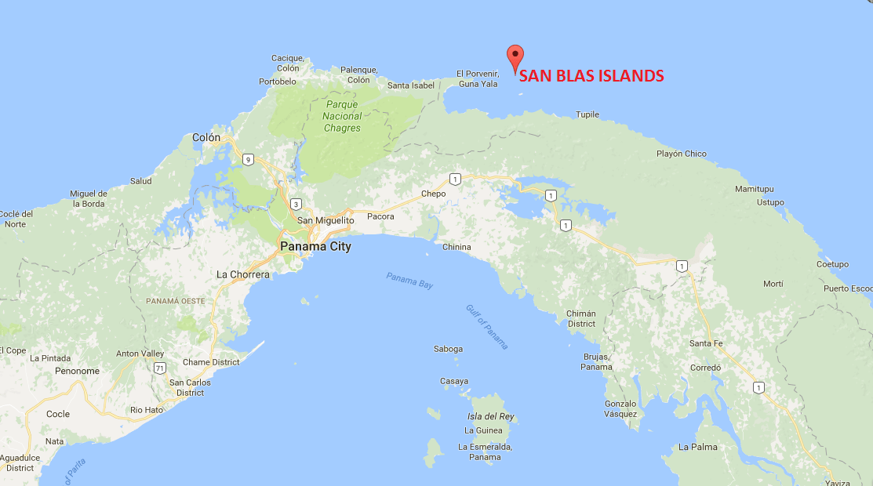
By the mid-1800’s, the Kuna began creating their designs for Molas by using a sewing technique called “Reverse appliqué”. A Mola maker places two or three pieces of different colored cloth on top of each other and bastes them together. Then she cuts into the top layer, cutting out her design. Only the bottom layer remains intact to be the background color and support the stitching of the other pieces. She hems all the cut edges with very, fine stitches, making sure that her thread exactly matches the color of the cloth. The color of each lower level creates the outline of the design.

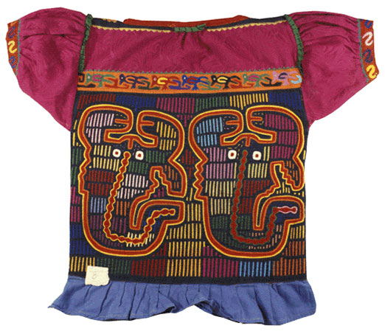

The subjects for the Molas draw on ideas or stories from Kuna history, culture, and beliefs. They usually portray birds, fish, family life, spirits, and cultural designs.

Meaning of the Mola

The main concept in Molas is to leave as little unworked space as possible, as the Kunas believe that evil spirits can settle in the free spaces. Based on this, several repeating filling elements can be found in traditional Molas.

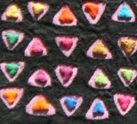 | These small, appliqued triangles symbolize the shape of the bamboo huts, being the home of the Kuna. They represent being protected by the family. | 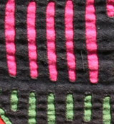 | The vertical slots imitate the sun beams shining through the bamboo walls of traditional Kuna homes. They also mean being protected by the family.
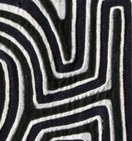 | Labyrinths are found on many Molas. Evil spirits get lost in labyrinths and the Kuna wearing these molas is being protected. | 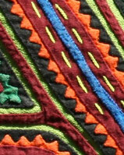 | Zig Zag lines are "dientes" or teeth biting away evil spirits.

Examples

Because the Kuna were a nomadic tribe, they did not make art in the form of statues or buildings; they instead decorated themselves with their artworks. Molas were sewn by Kuna women and girls to be worn as part of their dress ensemble.

